**Collect/Connect Read Me**

**Alpha Prototype**

(Unity Build 1 Instructions)

CIS 4951/4961

Team 8

24 December 2016

Table of Contents

Introduction/Background: 3

What Has Been Completed: 3

Walking Through the Prototype: 3

How to Download Unity: 3

Additional Notes: 4

# Introduction/Background:

We are very excited to show you all our alpha prototype build for the Collect/Connect game! We have most of the basic game play completed and are looking forward to completing the project next term. One thing to note, we were only able to get a Unity build executable working, meaning you will need to download the Unity program in order to run the game. Please see the “How to Download Unity” for further information on how to do so. There are screenshots below in the “Walk Through the Prototype” section if you wish to just see visuals of the game thus far. In this section, we will walk through a round of game play.

# What Has Been Completed:

As stated in the previous section, we have the basic game functionality completed including: start screen, game board outline/design, temporary card deck, player’s personal card enhancer (includes further information about the card), keyword section and selection, and each player’s turn. As the player plays their turn, the cards, keywords, and connections will appear on the game board. Please see the section below (“Walking Through the Prototype”) where we will run through a game round together.

# Walking Through the Prototype:

1. Click on the CCBuild1.exe file
2. Click the “Play” button at the bottom of the pop-up screen

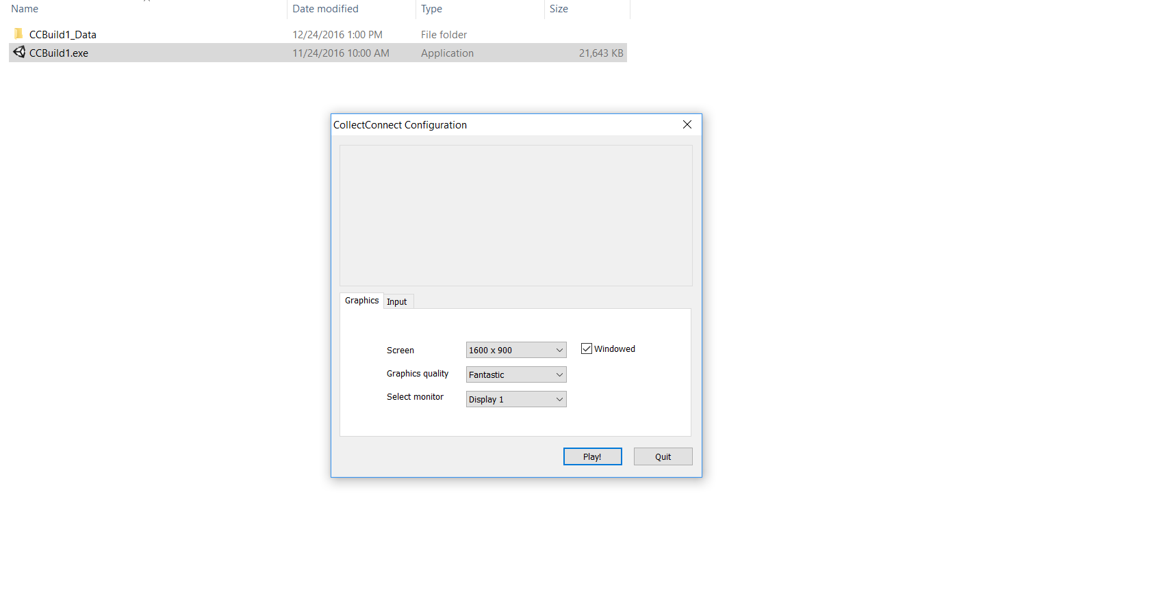

Step 1:

Step 2:

1. This should be the next screen that appears:

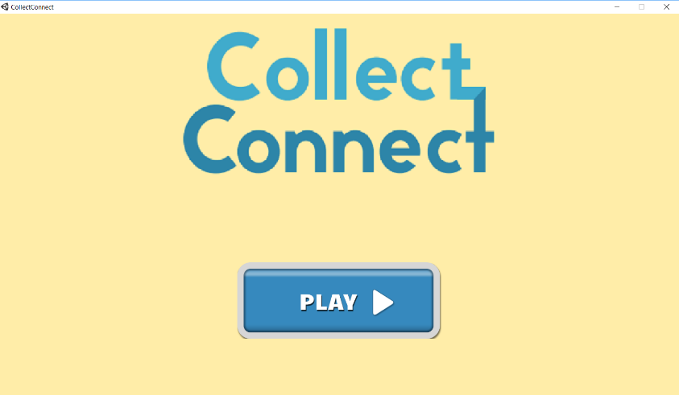

This is our main menu screen. Please keep in mind this is just a simple screen for now and will be “updated” to include directions on how to play the game, number of players, rounds want to play, etc.

1. 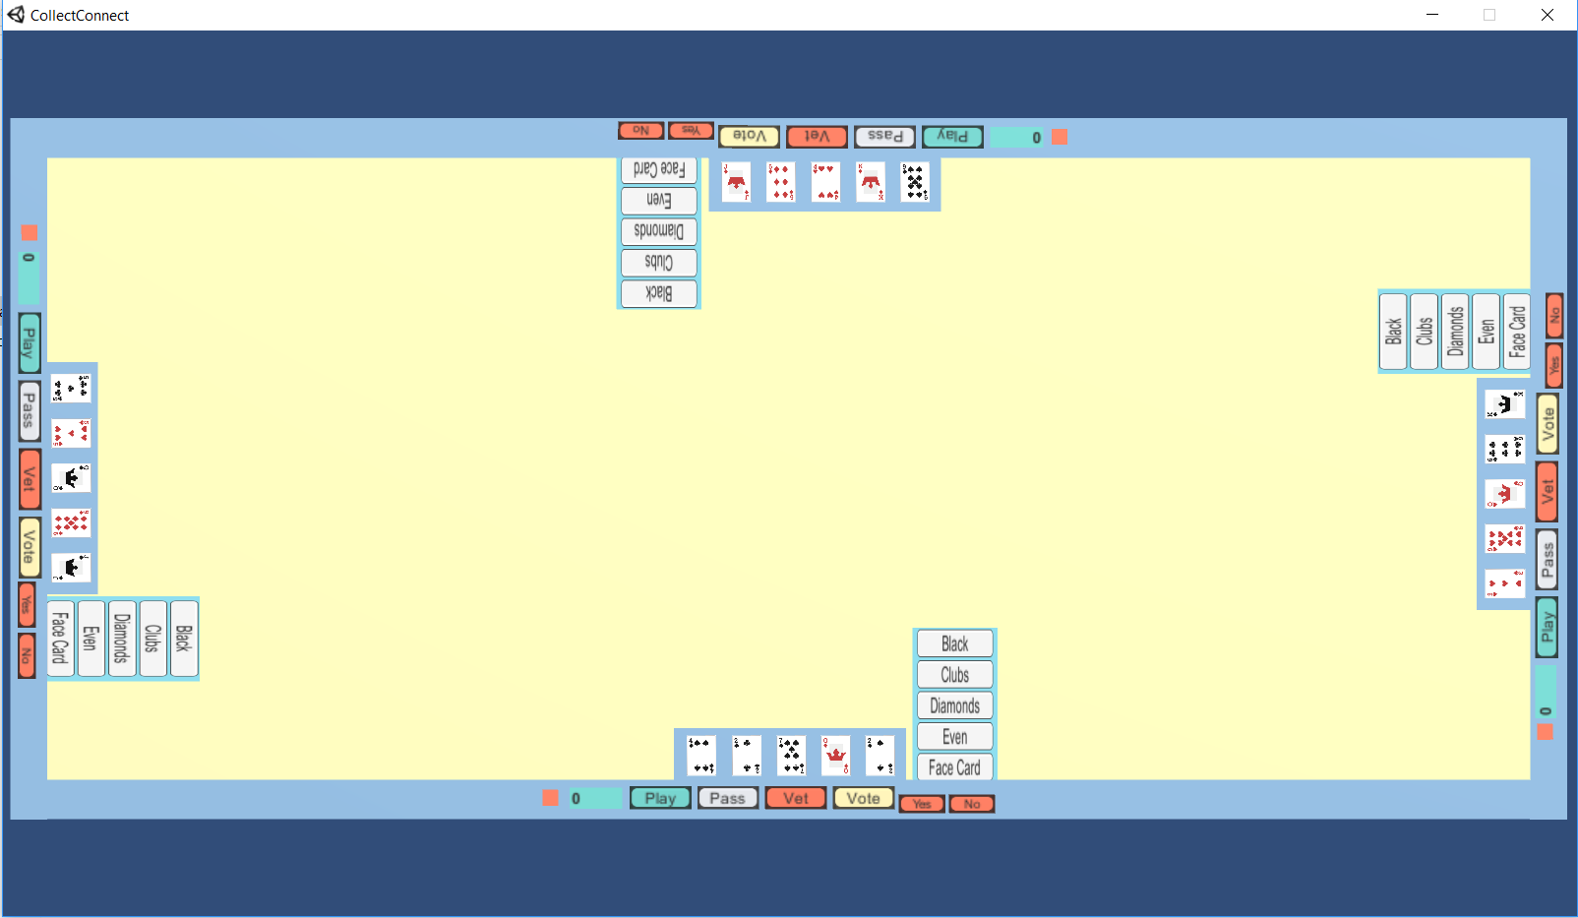Click the play button, and you will see this screen:

This is the main game board. It includes all four player’s personal “player boards” and the shared center game play area, where the cards and connections will be displayed. Included within the player’s personal “player board” is: their current cards, and a listing of the keywords (this list is scrollable). On the blue boarder (starting from left to right) includes, a menu button, player’s score, play button, pass button, vet button, vote button, and yes and no buttons for voting. None of these buttons nor the score are currently working, but this will be the next thing we are looking into completing.

Player one will be the first one able to play a card and connection/keyword. Player one is the player sitting at the top of the screen and the player count follows counter clockwise (player two is on the left, player three is at the bottom, and player four is on the right). No other players are able to play a card or connection/keyword until it is their turn to play. Players are able to “enhance” their cards to see a further description. In order to do this, click and hold the mouse over any card. You should get something similar to the image below:

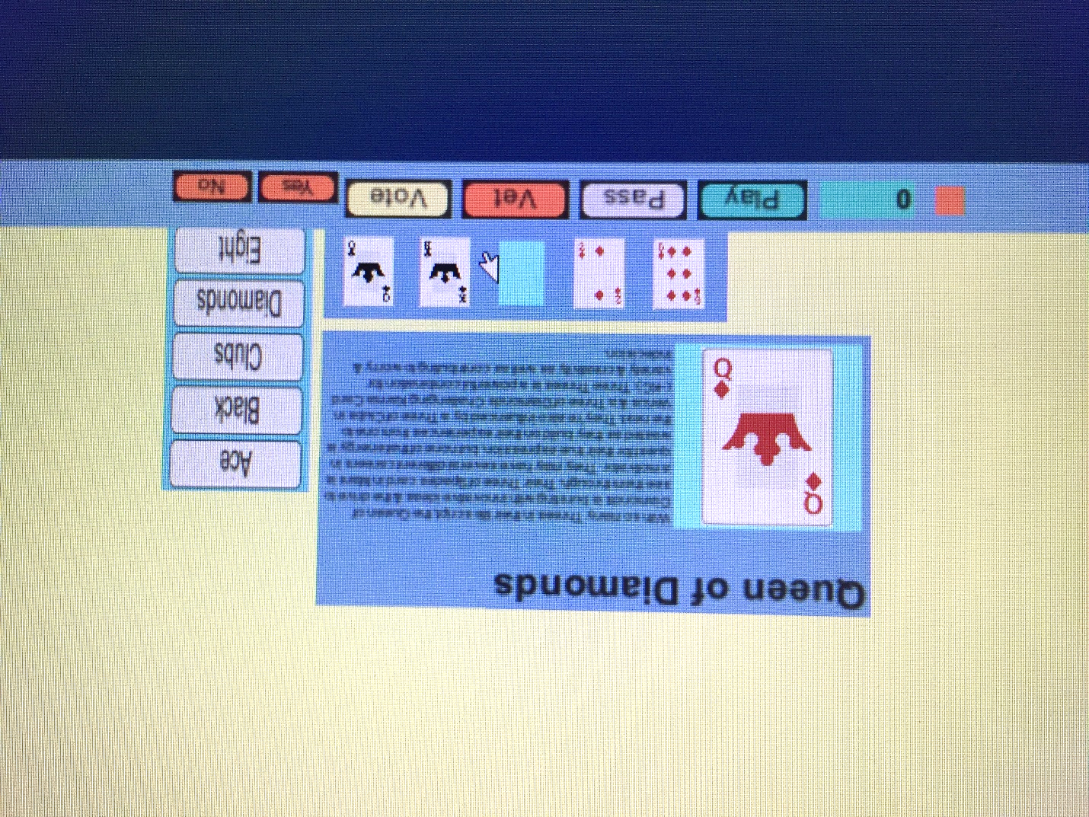

1. Player one will go first and they will select the King of diamonds. To show you have selected a card, it will shift right above your hand onto the board (this is only temporary and will be changed in further prototypes). In addition, the player will have to select a keyword that is within the cards “word bank”. For example, you cannot select the red Queen of diamonds and select the keyword “black”. This will be altered in future prototypes to allow players to create their own connections between artifacts. We should get the following screen:

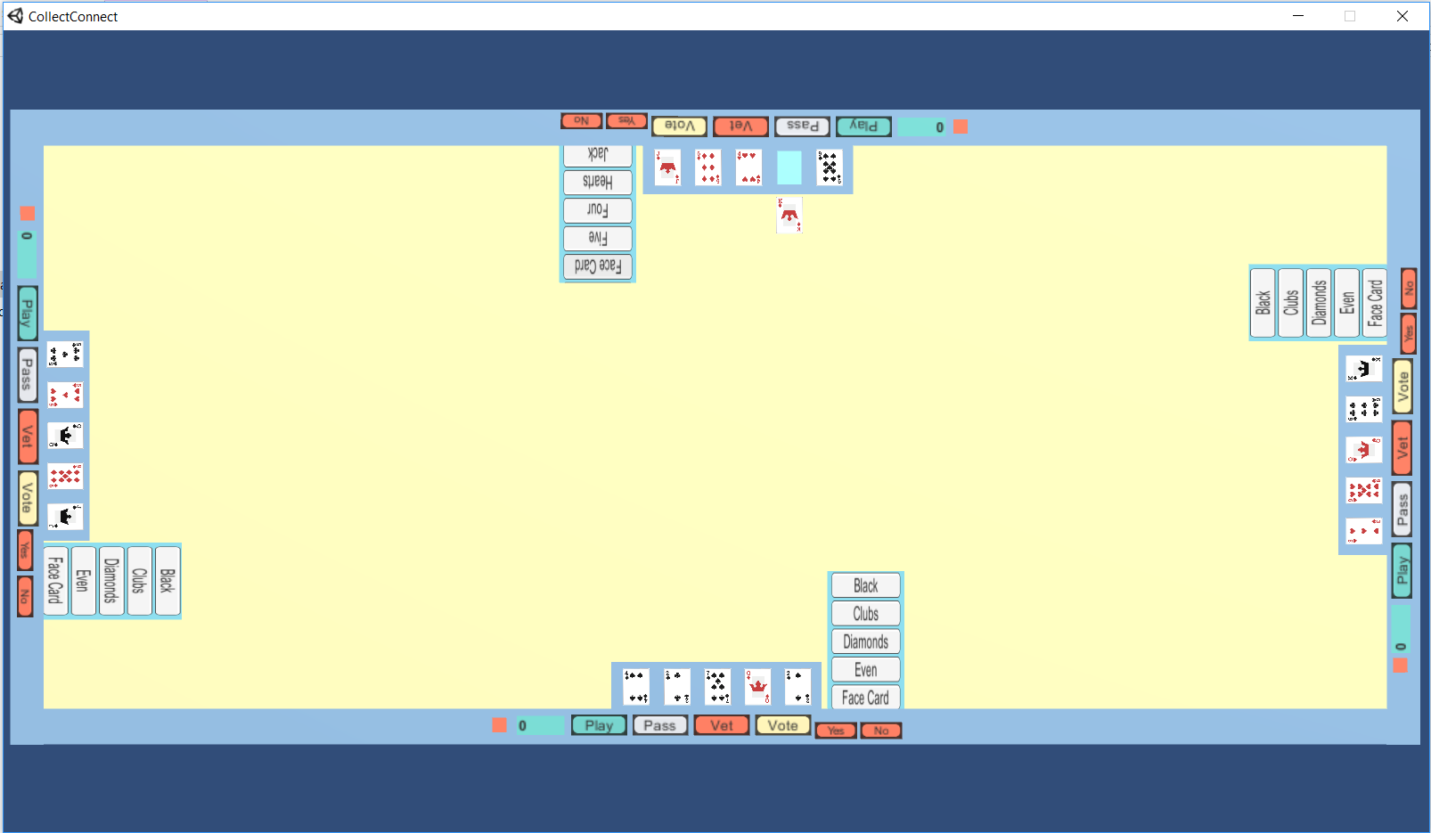

1. Now it’s player two’s turn. They will click on the nine of diamonds and then click on the “diamonds” keyword. Lastly, they will click on player one’s card (the King of diamonds) to connect the two together. We will get the following screen:

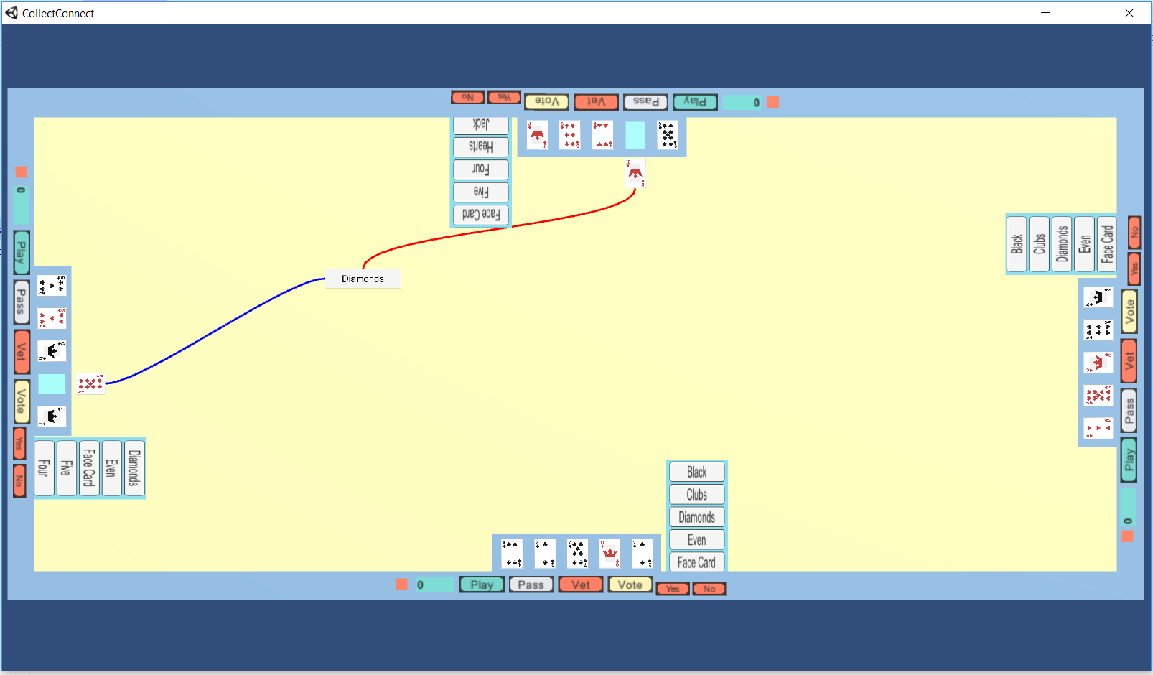

Step 1:

Step 3:

Step 2:

1. Now it’s player three’s turn. They will click on the Queen of diamonds and then click on the “face card” keyword. Lastly, they will click on player one’s card (the King of diamonds) to connect the two together.
2. Finally, it’s player four’s turn. They will click on the King of spades and then click on the “King” keyword. Lastly, they will click on player one’s card (the King of diamonds) to connect the two together. We will get the following screen displaying player three’s and four’s turns:

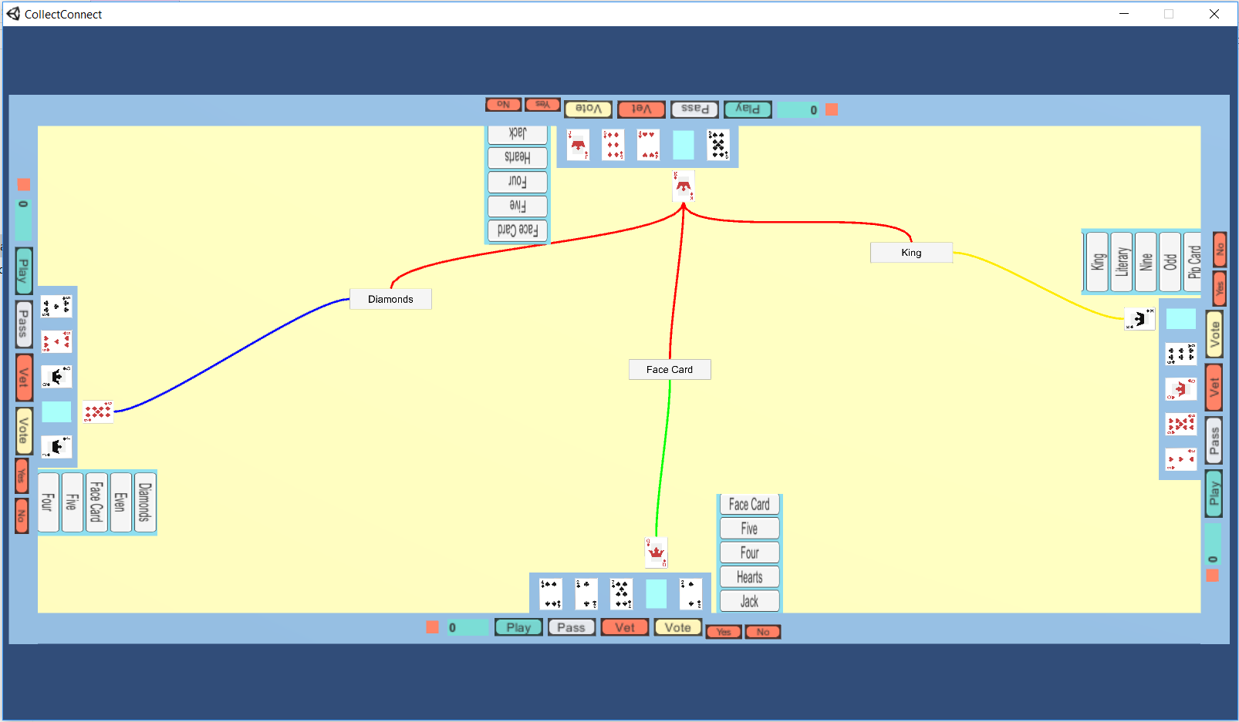

Each player has a different line connection color: player one is red, player two is blue, player three is green, and player four is yellow.

We have only tested through one round of game play so far, but you can continue to make further connections if you would like; they will all appear on the game board.

# How to Download Unity:

In order to run our executable on your own computer, you will need to download the Unity software. You can download the free personal edition here: <https://store.unity.com/download?ref=personal>. Please click the “Download Installer” lime green button, in the center of the screen, to begin the download process. Once the installer has downloaded, please run the installer and follow the prompts.

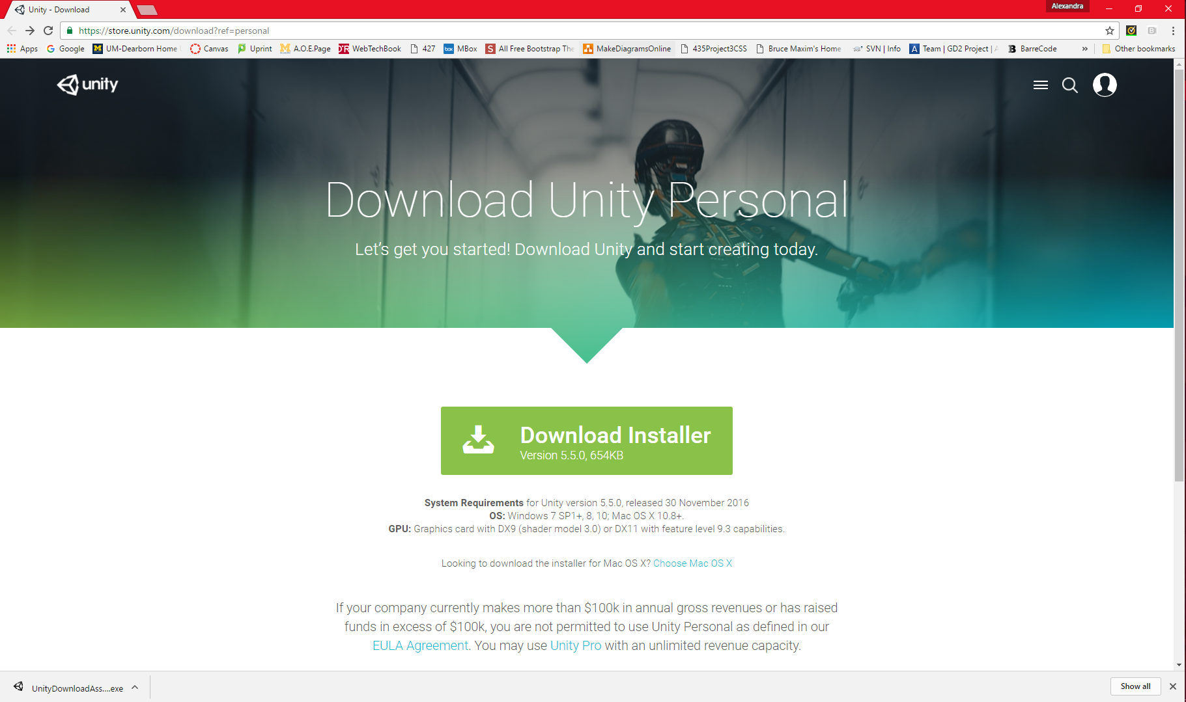

Step 1:

Step 2:

(If you already have Unity on your computer you should be able to run the game without having to redownload Unity.)

# Additional Notes:

We will be walking you all through our alpha prototype on Friday, January 13th, 2017. Please look out for an email from Jake Kuznicki specifying the time and location the meeting will be held.

Please feel free to email us throughout the break if you have any questions, comments, concerns, or suggestions with the prototype and we will email you back as quickly as possible. Please feel free to bring you questions, comments, concerns and suggestions to our next meeting (please see the paragraph above) as well.

We are looking forward to seeing you all on the 13th and hope you are enjoying the winter holiday.